Attention Residents and Business Owners

Ontelaunee Township is asking residents and business owners located on Gernants Church Rd., Indian Manor Dr., Koch Rd., Berkley Rd., Furnace Row, Helen Ln., and West Huller Ln. to participate in a Water Inventory Survey. Assistance with the survey will help to ensure compliance with new regulatory requirements.
Recent lead and copper rule revisions from the U.S. Environmental Protection Agency and Pennsylvania Department of Environmental Protection (PA DEP) have been implemented to further reduce the risk of lead exposure from drinking water. The update requires that water service providers build a complete inventory of pipes and service lines in their systems. Service lines are the customer-owned pipes connecting their home or business to the public water main in the street.
The new lead and copper rule revisions require all community water systems to submit a service line inventory to PA DEP by October 2024. The inventory will help identify and prioritize the replacement of high-risk materials that could potentially be a source of lead in drinking water.
The surveys will be mailed the week of January 15, 2024 and are due by March 1, 2024.
Please see an example of types of service lines and FAQS listed on the next page. If you still have additional questions, please contact the Water and Sewer Administrator at 610-926-4240 ex. 208.

Thank you for your assistance,
Ontelaunee Township
Example:
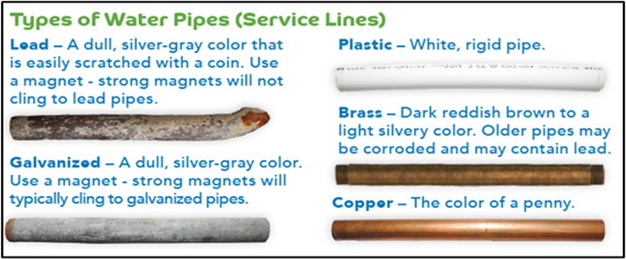

FAQS:
Why must we do this?
The US Environmental Protection Agency and PA Department of Environmental Protection require all community water systems to submit a service line inventory to PA DEP by October 2024.
Is there a cost to me?
Currently, we are only compiling data to complete an inventory.
What if I am unable to determine the material?
You can submit a photo to otws@comcast.net along with your name or address and one of our Public Works employees will attempt to determine the material, or you can contact 610-926-4240 ex. 208 to schedule an appointment for a Public Works employee to come to your home and determine the material.
I am not available to allow Public Works into my home. Is there another way to verify the material?
A picture can be emailed to otws@comcast.net and we will attempt to determine the material. Please include your name and address with any photos submitted.

